1. **What Employees work at which Stores?**

SELECT Employee.EmployeeID as EmployeeID, Store.StoreID as StoreID, Store.Revenue as Revenue, Store.City as SCity, Store.StreetName as SStreetName, Store.ZipCode as SZipCode, Store.State as SState, Employee.Salary as Salary, Employee.HourlyRate as HourlyRate, Employee.State as EState, Employee.City as ECity, Employee.ZipCode as EZipCode, Employee.StreetName as EStreetName, Employee.FName as FName, Employee.LName as LName

FROM Store JOIN Employ USING (StoreID) JOIN Employee USING (EmployeeID);

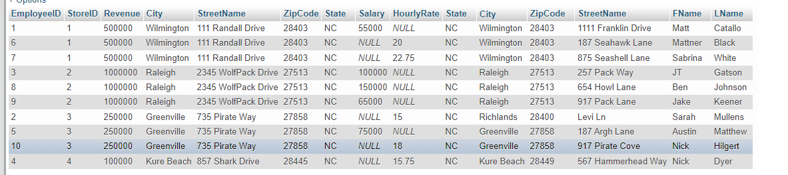

1. **What Store makes the most revenue?**

SELECT *

FROM Store

WHERE Store.Revenue = (SELECT MAX(Store.Revenue) FROM Store);

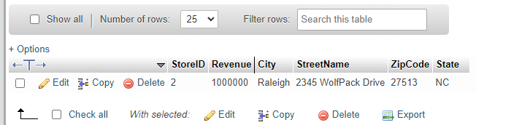

1. **What Employee has had more than 1 sales transaction lately?**

SELECT Employee.EmployeeID as EmployeeID, Employee.FName as FName, Employee.LName as LName, Count(*) as NumberCount

FROM Employee JOIN Sell USING (EmployeeID)

GROUP By Employee.EmployeeID

Having NumberCount > 1;

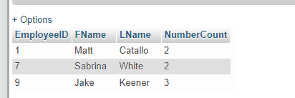

1. **What is the average cost of our merchandise?**

SELECT ROUND(AVG(Merchandise.Cost),2) as AvgCost

FROM Merchandise;

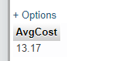

1. **What merchandise(s) cost more than the “Dokken Album”?**

SELECT m2.MerchandiseID as ID, m2.Cost as Cost, m2.Type as Type, m2.MerchName as Name, m2.StoreID as StoreID

From Merchandise as m1, Merchandise as m2

WHERE m1.MerchName LIKE "Dokken Album" AND m2.Cost > m1.Cost;

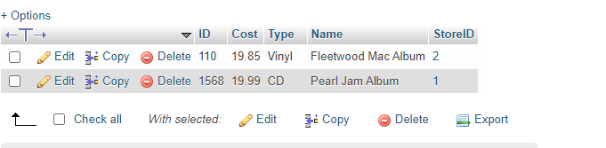

1. **What Employees are paid Hourly?**

SELECT Employee.EmployeeID as ID, Employee.HourlyRate as HourlyRate, Employee.State as State, Employee.City as City, Employee.ZipCode as ZipCode, Employee.StreetName as StreetName, Employee.FName as FName, Employee.LName as LName

FROM Employee

WHERE Employee.Salary is null;

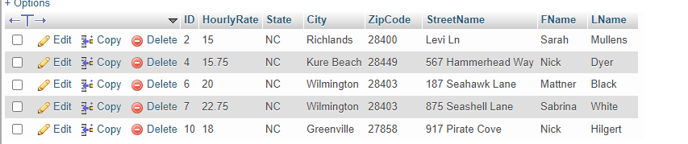

1. **What Employees have their First Name start with “N”?**

SELECT Employee.EmployeeID as ID, Employee.HourlyRate as HourlyRate, Employee.State as State, Employee.City as City, Employee.ZipCode as ZipCode, Employee.StreetName as StreetName, Employee.FName as FName, Employee.LName as LName

FROM Employee

WHERE Employee.FName LIKE "N%";

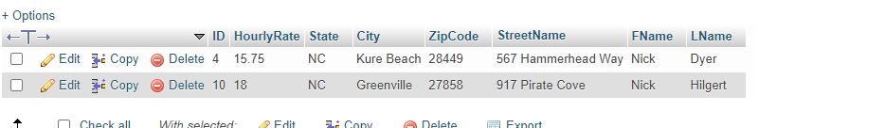

**CalcAddress:**

DELIMITER $$

CREATE DEFINER=`tfb8630`@`localhost` FUNCTION `calcAddress`(StreetName VarChar(50), City VarChar(50), State VarChar(50), ZipCode int) RETURNS varchar(250) CHARSET utf8mb4

DETERMINISTIC

BEGIN

RETURN CONCAT(StreetName, Char(10), City, ", ", State, " ", Zipcode);

END$$

DELIMITER ;

1. **Use the function calcAddress to show the addresses of salary employees.**

SELECT calcAddress(Employee.StreetName, Employee.City, Employee.State, Employee.ZipCode) as Address, Employee.FName as FName, Employee.LName as LName

FROM Employee

WHERE Employee.HourlyRate is null;

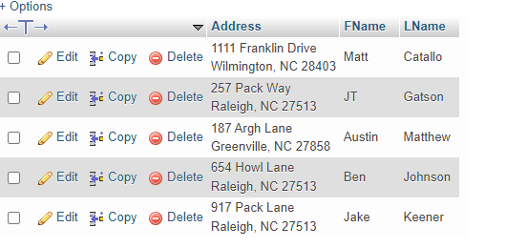

**SalaryDIST procedure:**

DELIMITER //

CREATE PROCEDURE salaryDIST (OUT minimum DECIMAL(8,2), OUT maximum DECIMAL(8,2), OUT average DECIMAL(8,2))

BEGIN

SELECT MIN(Employee.Salary) INTO minimum

FROM Employee;

SELECT MAX(Employee.Salary) INTO maximum

FROM Employee;

SELECT AVG(Employee.Salary) INTO average

FROM Employee;

END //

DELIMITER ;

1. **Use salaryDIST to show a glimpse of the salary distribution**

CALL salaryDIST(@minimum , @maximum , @average);

SELECT @minimum as MinimumSalary, @maximum as MaxmiumSalary, @average as AverageSalary;

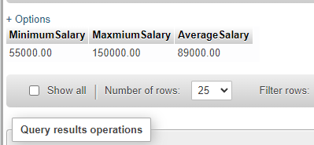

1. **Trigger to update Merchandise in case a store must close down due to funding and the merchandise can switch to the store with the highest revenue.**

CREATE TRIGGER `updateMerchandise` BEFORE DELETE ON `Store`

FOR EACH ROW BEGIN

DECLARE IDStore INT;

SELECT Store.StoreID into IDStore FROM Store Where Store.Revenue = (SELECT Max(Store.Revenue) FROM Store);

UPDATE Merchandise SET Merchandise.StoreID = IDStore WHERE old.StoreID = StoreID;

END

**\*I created a fake store to showcase the trigger\***

**Before Trigger:**

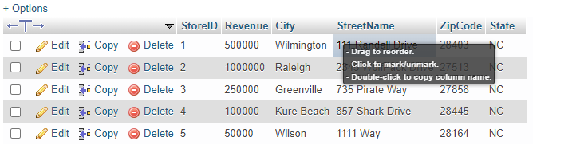

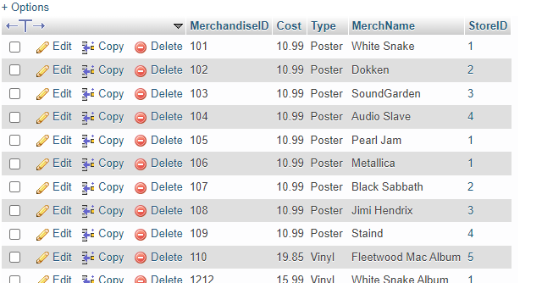

**After Trigger:**

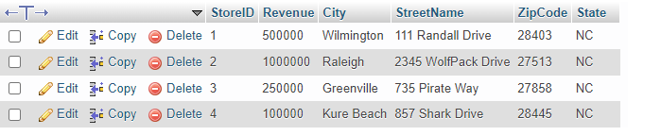

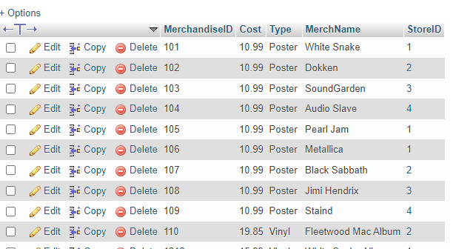

“Fleetwood Mac Album” is now at the store with the highest revenue.

**Front End Instructions**

**Main Link:**

Links: <https://ada.cis.uncw.edu/~pmj3349/CSC455Final.php>

Query 1- <https://ada.cis.uncw.edu/~tfb8630/EmployeeStore.php>

Query 2- <https://ada.cis.uncw.edu/~tfb8630/MostRevenue.php>

Query 3- <https://ada.cis.uncw.edu/~cab5407/CSC-455/query3.php>

Query 4- <https://ada.cis.uncw.edu/~cab5407/CSC-455/query4.php>

Query 5- <https://ada.cis.uncw.edu/~lcd4211/query5.php>

Query 6- <https://ada.cis.uncw.edu/~lcd4211/query6.php>

Query 7- <https://ada.cis.uncw.edu/~tfb8630/NamesStartN.php>

Query 8- <https://ada.cis.uncw.edu/~tfb8630/FunctionCall.php>

Query 9- [https://ada.cis.uncw.edu/~pmj3349/Query9.php](https://ada.cis.uncw.edu/~tfb8630/FunctionCall.php)